Name – Shashank Chauhan
CSE-D
Roll no. - 2400290100284

MSE-1
- GitHub repository URL
https://github.com/Shashank01-hub/github-skills-challenge
2. Pull request URL used to validate the workflows
https://github.com/Shashank01-hub/github-skills-challenge/pull/2

- Screenshot showing the GitHub Actions workflows
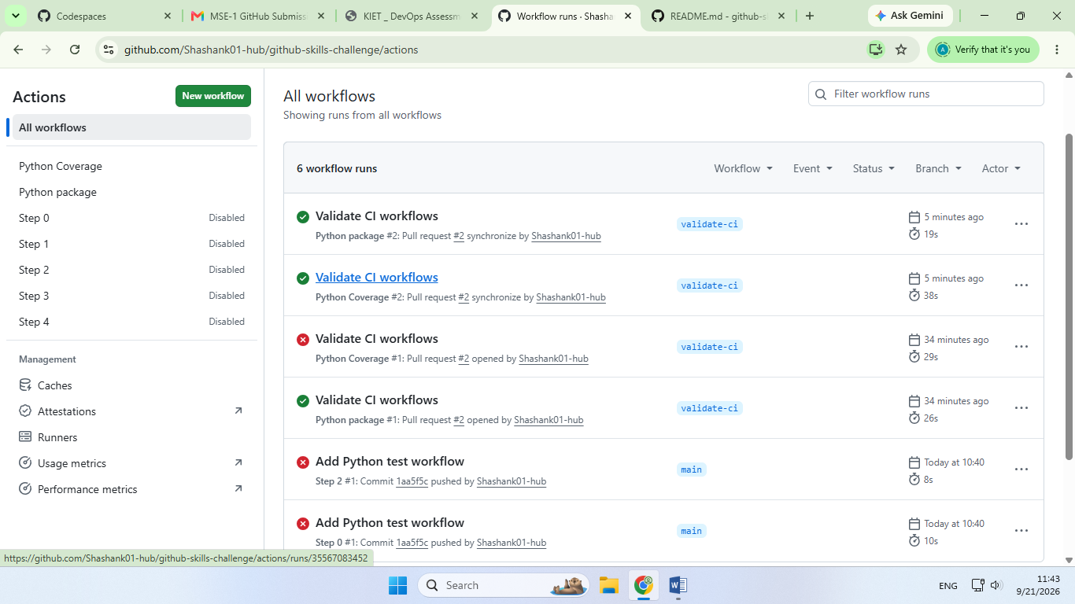

- Screenshot showing a successful test workflow execution
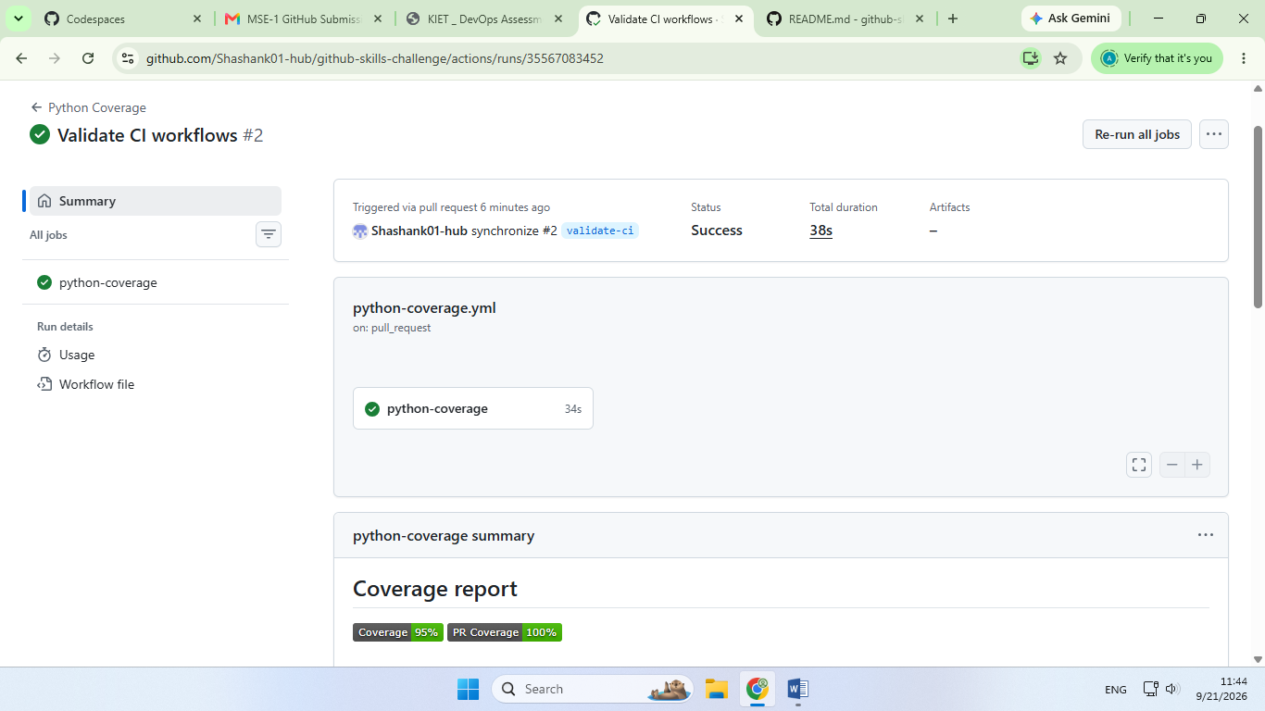

- Screenshot showing the coverage result/comment on the pull request
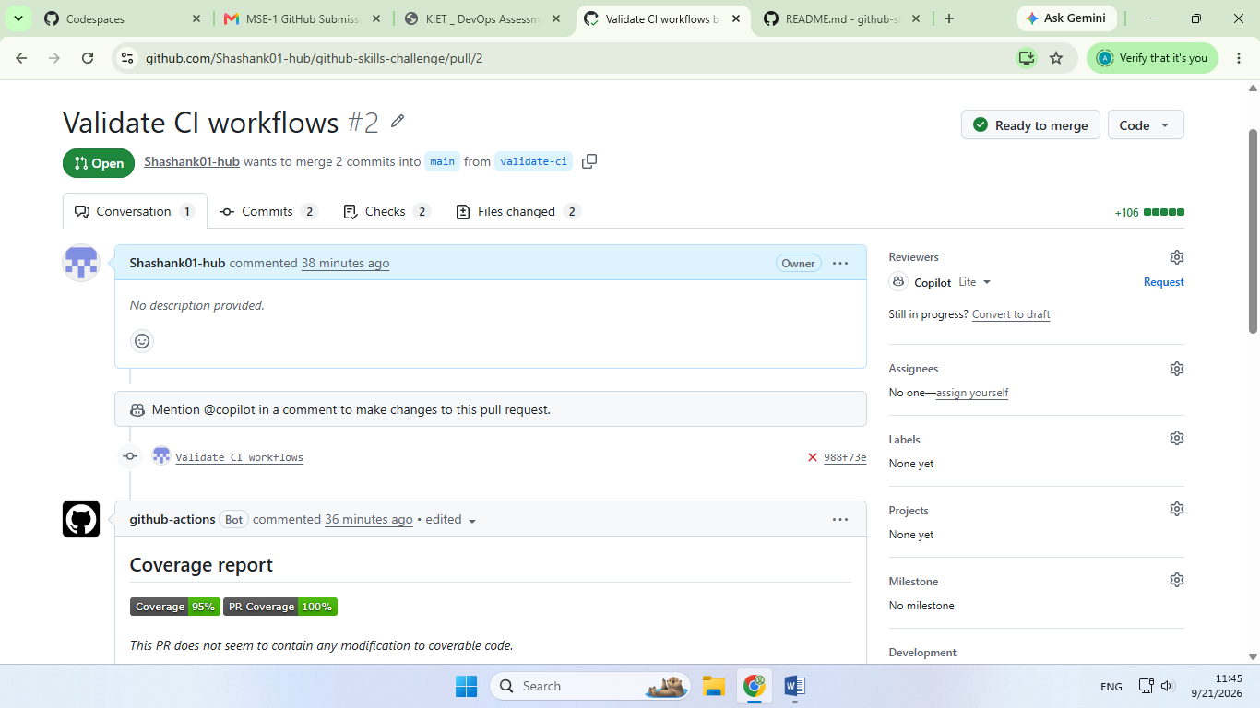

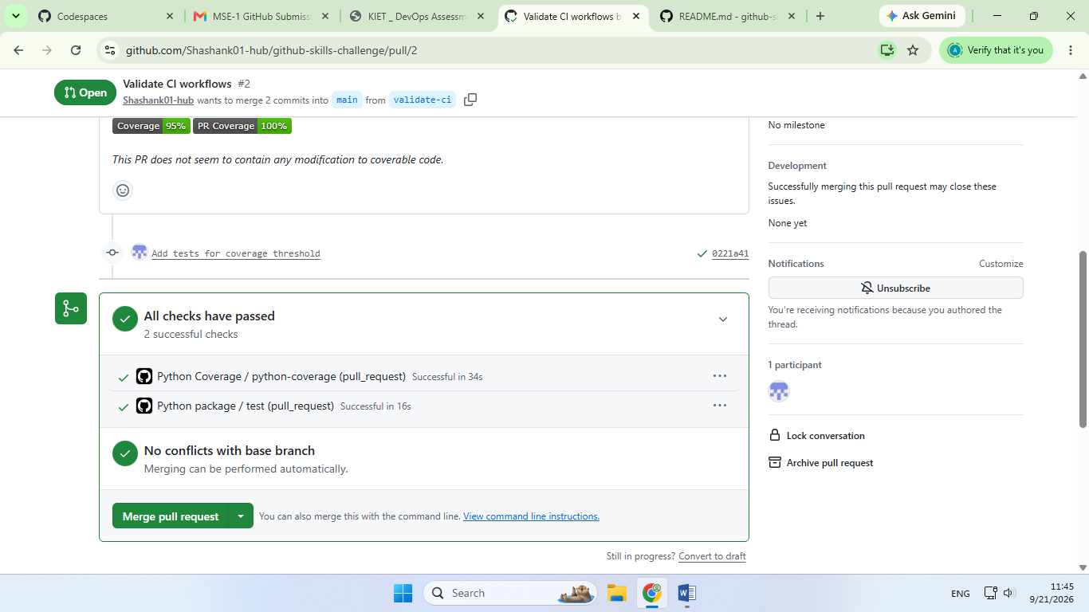

- Screenshot showing the final repository/workflow files
